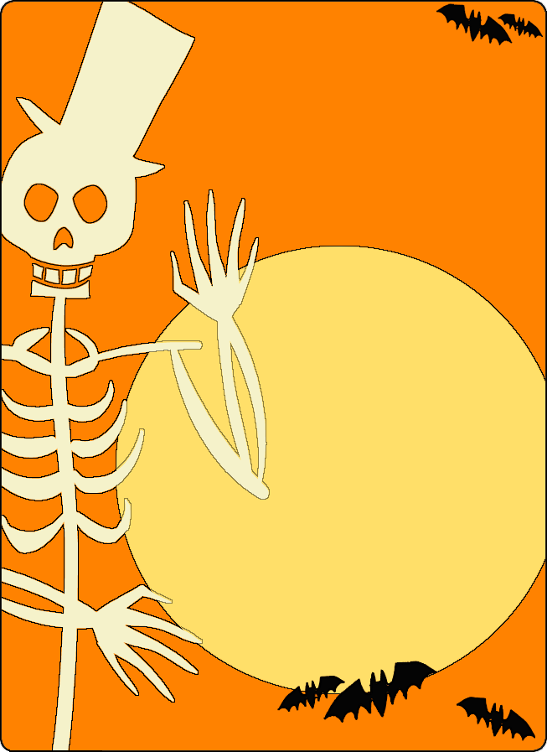
Heritage Crossings Presents our first Ever outdoor Movie Night Featuring Disney’s “Hocus Pocus”

October 13th 6:00PM -social hour. 7:00PM- show time.

501 N 13th St

Geneva, NE 68361
Please join us for a free outdoor movie night. Bring your own lawn chairs and blankets! (Plan for chilly weather) The movie will take place on the East side lawn behind the cottages.
Popcorn, treats, water, lemonade, and hot chocolate will be provided, served at the West cottage.
Look for the designated parking area to the North of the lawn.

We will plan a rain date of October 20th

